**The Heart And Vessels**

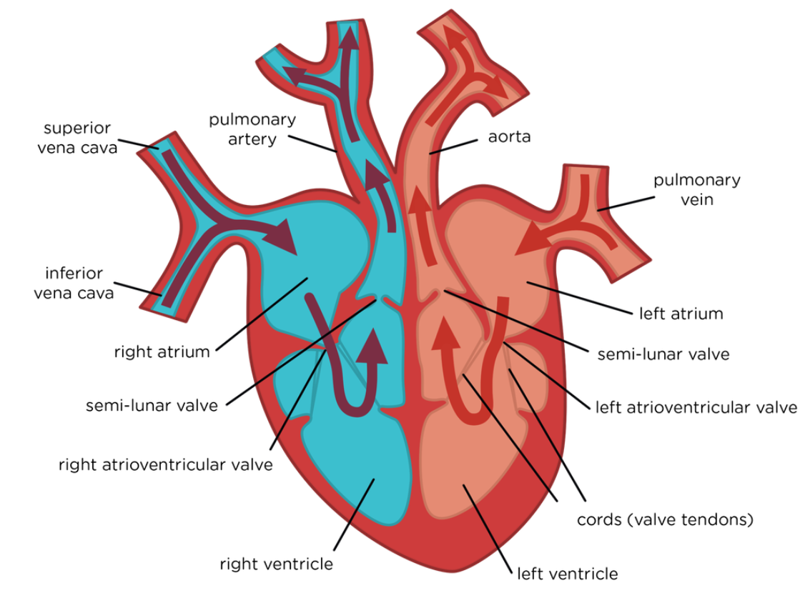

Atrial Systole:

* Atria contract
* A-V valves pushed open by pressure
* Blood pushed to ventricles
* S-L valves closed to stop backflow

Ventricular Systole

* A-V valves close to stop backflow – no pressure to open them
* Ventricles contract
* S-L valves open by pressure
* Blood pushed through Arteries

Cardiac Diastole:

* Atria relaxed and filling
* A-V valves partially open, so ventricles relaxed partially filling
* S-L valves closed to stop backflow